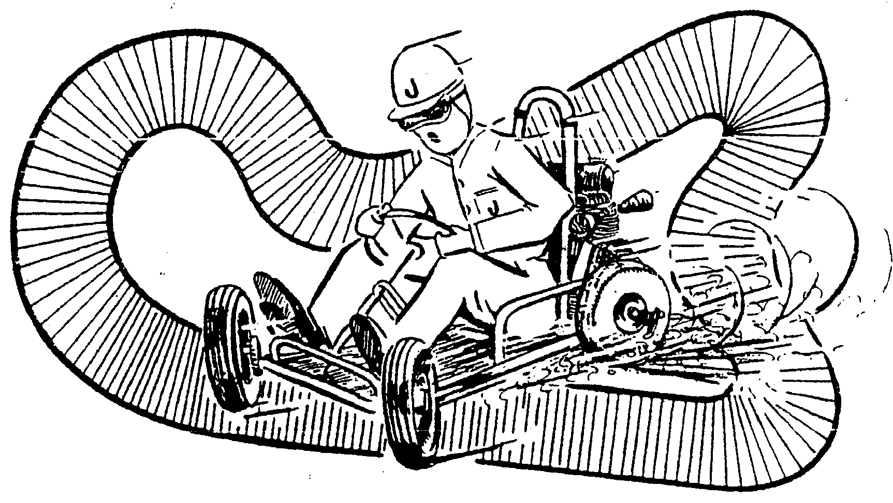
VINTAGE AND HISTORIC KARTS AUSTRALIA INCORPORATED

APPLICATION FOR MEMBERSHIP
Authorised by Vintage and Historic Karts Australia please send to The Secretary 121 Lurline St Katoomba
Email philipparkinson@pip.com.au

I …… … … … … … … … … … … … … … … … … … … … … … … … …… … …
(Full name of applicant)

Of ……………………………………………………………………………………………….
(Address - must indicate place of residence and post code)

Phone Number …………………………….. Fax Number ………….……………………

Mobile Number… … … … … … … … …..

E-mail …………………………………………………….……..

Current Kart Licence (if any) ………………………………………………………………..
(Including State and Number)

…………………………………………………………………………………………………..

I hereby apply to become a member of the above named incorporated association. In the event of my admission as a member, I agree to be bound by the rules of the association for the time being in force. My membership fee of $50.00 is enclosed and I understand that my membership for the proceeding years is set at $25 to be payed annually.

…………………………………………… …………………………………...
Signature of applicant Date

I, a member of the association,
(Full name)

Nominate the applicant, who is personally known to me, for membership of the association.

…………………………………………… …………………………………...
Signature of proposer Date

I, a member of the association,
(Full name)

Second the nomination of the applicant, who is personally known to me, for membership of the association.

…………………………………………… …………………………………...
Signature of seconder Date

Please feel Free to copy and pass to interested people.

